ENGLISH ABSTRACT
How do operating room nurse students experience the learning environment in the operating room?
Background: There is little research-based knowledge about how operating room nurse students experience the learning environment in the operating room. Results from a few international studies indicate that structural challenges such as time pressure, high demands of effectivity, and little time deligated to guidance are all characteristic of the learning environment. More insight into how operating room nurse students experience the operating room is an important part in improving the quality of practical studies in a high-tech and time-effective environment.
Goal: The purpose of the study is to describe operating room nurse students’ experiences of their learning environment in operating rooms.
Methodology: The study has a qualitative and descriptive research design, utilizing systematic text condensation as its analysis method. Data is gathered through focus-group interviews with operating room nurse students in their final part of the education program
Results: Three main categories were brought up repeatedly by the students: 1) the significance of supervisors, 2) unresolved supervisor responsibility in formal and informal supervision in a multidisciplinary learning environment, and 3) a complex and unpredictable learning environment.
Conclusion: The results give further insight into operating room nurse students’ experiences of their learning environment in authentic practice studies. The result can be utilized in further advancing the learning environment for operating room nurse students.
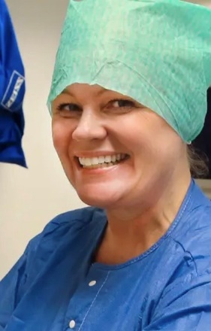

Lena Rengård Kolstad
Høgskolelektor
Lovisenberg diakonale høgskole, Avdeling MEVU
Programansvarlig ved Master i klinisk operasjonssykepleie ved Lovisenberg diakonale høgskole og emneansvarlig i sykepleieemnene MOPSA-100 Grunnleggende operasjonssykepleie og B1 fordypningsoppgaven ved videreutdanningen.

Forskningsinteresser:
Utdanningskvalitet for operasjonssykepleiestudenter og utvikling av gode pedagogiske utdanningsløp. Styrking av samarbeidet mellom klinikk og høgskole.

Bente Thyli
Førstelektor
NTNU. Institutt for helsevitenskap Gjøvik

Emneansvarlig innen master i avansert klinisk sykepleie. Underviser i master, videreutdanninger og innen bachelor sykepleie ved NTNU, Institutt for helsevitenskap Gjøvik.

Forskningsinteresser:
Sykepleie som fag og profesjon, utdanningskvalitet i sykepleie, pedagogikk, avansert klinisk sykepleie i kommunehelsetjenesten, flerkulturell sykepleie, eldreomsorg.

