Abstract for NORNA 2020
Title: “Splash basins- clean or contaminated?” A quantitative study on bacterial growth in splash
basins used to clean surgical instruments perioperatively.
Background and purpose: Surgical nurses should focus on preventing postoperative
infections and promote patient safety. Part of the work consists in identifying potential
sources of contamination and eliminating these. This study´s aim was to uncover potential bacterial
growth in surgical instruments splash basins during operations, and to point out which
variables can affect this.
Method: Quantitative method of collection, cultivation and analysis of water samples
obtained at operations performed on the thoracic and neurosurgical
department, to identify bacterial growth. A data collection form was made, for mapping
different variables.
Results: Cultivation showed growth of bacteria from the splash basins on both departments.
Bacterial growth was found in 44% of the final samples, respectively 41% from the thoracic
surgical and 47% from neurosurgical department. There is no evidence of a correlation
between bacterial growth and department, length of operation, number of persons in the
operating room or the amount of door openings. The most common types of bacteria found
were coagulase negative staphylococci and Micrococcus Luteus.
Conclusion: The study shows that the splash basin gets contaminated with bacteria. The
bacteria detected may be pathogenic. The findings are congruent with findings made in other
studies, and it is therefore recommended not to use splash basins. There should be more
research on this site, in order to conclude what is the best practice regarding cleaning
instruments perioperatively.
Key words: Splash basin, operating room, surgery, bacterial load
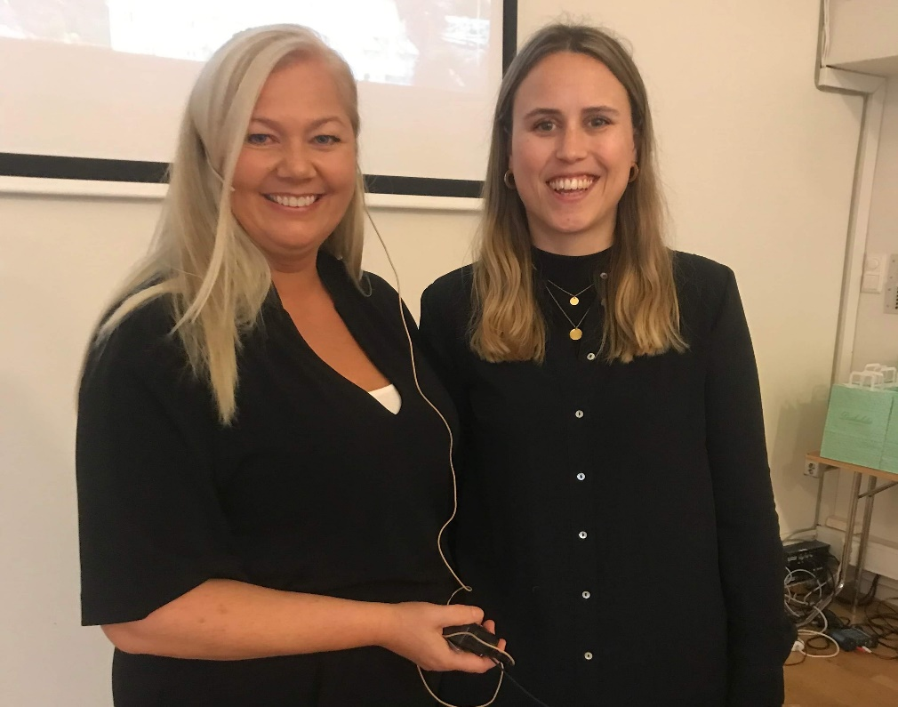

Linda Helen Helgeland  Surgical Nurse and MSc  Grimseidåsen 59  5239 Rådal  Tlf.: 99 36 58 13  Mail: lindahelgeland@gmail.com  45 years old. Currently working at the Department of Thoracic surgery at Haukeland University Hospital in Bergen, Norway. | Karoline Stavang Michalsen  Surgical Nurse and MSc  Steinsvikvegen 262  5237 Rådal  Tlf: 92 05 33 41  Mail: karoline.michalsen@gmail.com  31 years old. Currently working at the Department of Gastrointestinal surgery at Haukeland University Hospital in Bergen, Norway.

Institute: Department of Health and Caring Sciences,
Western Norway University of Applied Sciences (HVL) in Bergen, Norway.

Preferred type of presentation: Poster

